**Ideation Phase**

**Define the Problem Statements**

|  |  |
| --- | --- |
| Date | 31 January 2025 |
| Team ID | LTVIP2025TMID32102 |
| Project Name | SmartSDLC – AI-Enhanced Software Development Lifecycle |
| Maximum Marks | 2 Marks |

**Customer Problem Statement Template:**

Create a problem statement to understand your customer's point of view. The Customer

Problem Statement template helps you focus on what matters to create experiences people

will love.

A well-articulated customer problem statement allows you and your team to find the ideal

solution for the challenges your customers face. Throughout the process, you’ll also be able

to empathize with your customers, which helps you better understand how they perceive

your product or service.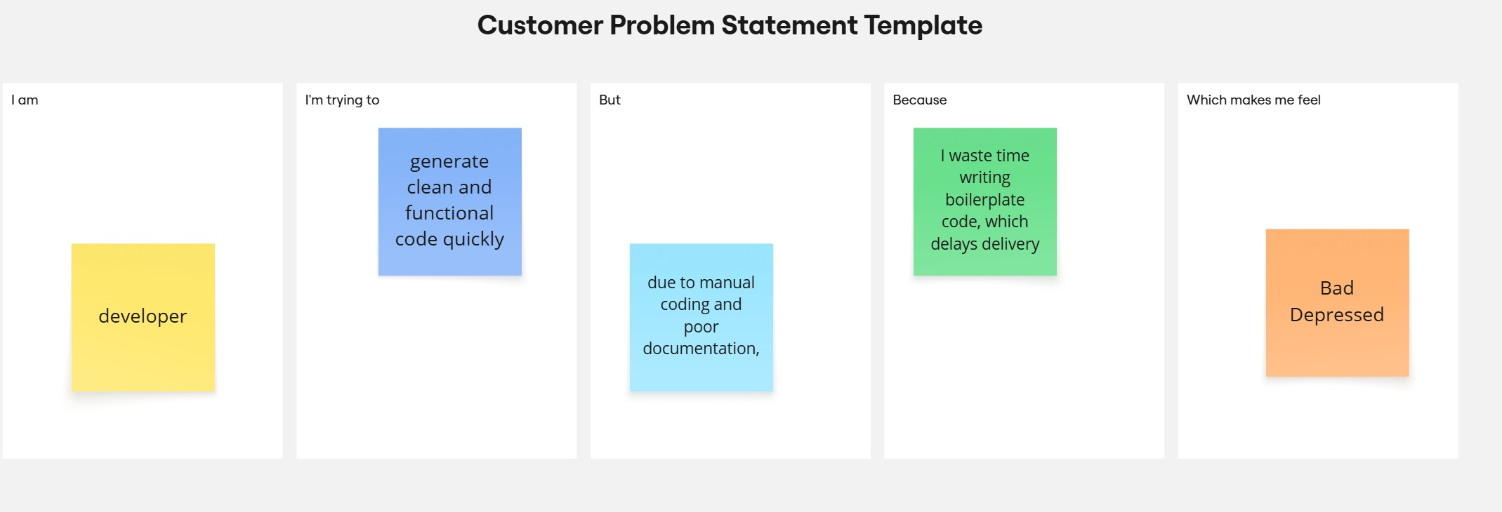

|  |  |  |  |  |  |
| --- | --- | --- | --- | --- | --- |
| Problem Statement (PS) | I am (Customer) | I’m trying to | But | Because | Which makes me feel |
| PS-1 | a developer | to generate clean and functional code quickly | due to manual coding and poor documentation | I waste time writing boilerplate code, which delays delivery | frustrated, overwhelmed |
| PS-2 | a project manager | keep documentation and requirements up to date | the lack of automation and context-aware tools makes it inefficient | Gaps between development and stackholder | frustrated, overwhelmed,  sad |